Index

Introduction 3

Usage 4

Installation 4

Compile 4

Run 4

Projects 5

Creating a Project 5

Opening a Project 5

Deleting a Project 6

Interface 7

Assets 8

Entities and Components 9

Animation Controller 10

Scripting 11

Physics 12

collisions 13

Introduction

Dear User, first of all we would like to introduce the O(no) game engine. It is a game engine that was created as a group project by 7 students of the Computer Science with High Performance graphics and Games Engineering course at the University of Leeds.

The O(no) engine was created with the focus on allowing it’s users to develop 3d isometric games but it can be used to create other kinds of games.

The following sections will describe the core aspects of the engine, teaching new users why things are needed and showing them how to create and use them in our engine.

Usage

The steps necessary to use the engine will be described on this section.

Installation

To install the game engine, you should access the github repository of the project, available on the following address:

<https://github.com/SpartanPawnch/COMP5530M-Group-Project>

And download the latest version, either by downloading as a zip or using the git clone command.

Compile

Description of how to compile.

Run

Description of how to run, starting by the launcher and telling the user why the projects folder is needed and how to choose it.

Projects

The first step to start creating a game using the engine is to create a project, so that everything that is related to the game is stored correctly.

Creating a Project

To create a project you should open the launcher as explained in the run section on the usage chapter. Then you will see a button on the top right corner (step 1 on figure X) that when clicked will open a propt to configure the new project. After configuring, press create project and click the project on the list of projects to open it in the engine.

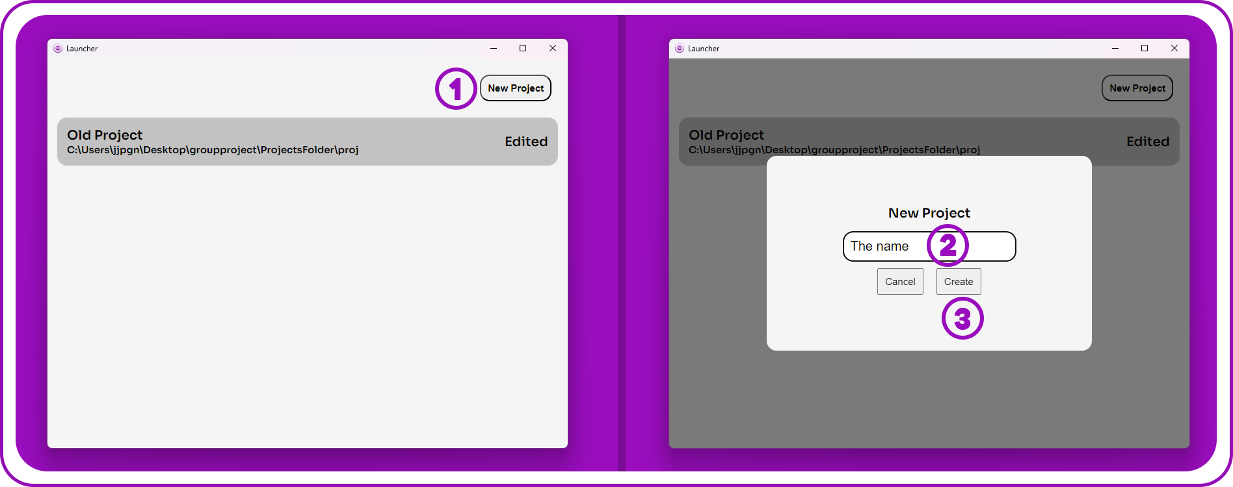

Figure x – Steps required to create a project

Opening a Project

To open a project that was created previously, open the launcher, choose the project you want to open from the list of projects and click it, the engine will be launched with your project.

Figure x – Steps required to create a project

Deleting a Project

To delete a project, open the launcher, choose the project you want to delete from the list of projects and click the delete button.

Figure x – Steps required to create a project

Interface

To use the engine, it is important to understand the purpose of the elements that compose the interface. In this section, the main areas of the interface will be described and explained. When describing the tabs, the position indicated will be the default one when opening the engine, but, tabs can be repositioned by dragging, so, the position may not be the same for you because you repositioned the tab.

Menu Bar

The menu bar contains two options. File, that can be used to Create projects, Open projects, Save projects and Save Levels. Build, that allows you to build and run the project so that you can preview your game.

Editors

The engine has different editors, the main editor is the game editor that can be used to control every aspect of the game, but, for some users, there needs to be a higher level of control that abstracts some aspects that require background knowledge about game development so, the other tabs were created to help on that, being them the UI Editor to edit the game interface, the Character editor to edit characters, works both for player characters and enemy characters, and the world editor to create worlds for the game. The tabs can be selected on the top left corner of the engine.

Entities List

Entities will be described in more detail in section Entities and Components, but scenes are made of entities and the entities list is where it is possible to create, reposition in the hierarchy and delete entities.

Levels List

The levels list can be accessed by pressing the Levels tab on top of the entities list. Levels will also be explained with in detail in section Levels but the game is composed of multiple levels and the default and current level can be set from the Levels list. It can also be used to create, delete and rename levels.

Viewport

The viewport is where the entities in the current level are rendered as a preview. Left clicking an entity will select in and guizmos will appear to reposition it. Right clicking the viewport will make you enter control mode that will allow you to use W,A,S and D keys to move around, you can move with more speed by pressing SHIFT while moving and move slower by pressing CTRL while moving, right clicking again exits that mode.

Style Editor

The style of the entire engine can be edited on this tab to make it more custom, it is the first tab on the top right side of the engine.

Properties

Entities have components that will be described in more detail on the Entities and Components tab, but allow to add more customization to the entities. When an entity is selected from the list of entities, the name, transform and list of components it has is displayed on the properties tab. Components can be added to the selected entity by using a right click menu.

Asset Browser

The need of assets and how to manage them will be described in detail on the Assets section, but, to customize the game there is a need to use assets. The assets browser allows the users to manage the assets from the project.

Log

Some actions will make text appear on the log tab. Don’t be scared, most of the texts in the log will not mean that an error happened, but will only be written to ensure everything is working as normal. To confirm if the written text has been an error, erros start with “ERROR-“.

Assets

This is the index

Levels

This is the index

Entities and Components

This is the index

Animation Controller

This is the index

Scripting

This is the index

Physics

This is the index

collisions

This is the index